THE WOLDS BRANCH PPG
Notes of the meeting held on Friday 2 February 2024

Present: Sue Walker (Chair)
June MacInnes
Marlene Renshaw
Jane Williams
Graham Wilde
Andrew Camm
Dr Neal Parkes
Mickaela Crane
Jackie Fletcher
Maria Wilde

Apologies: Diane Fathers
Marie Newmarch
Margaret Schubert
Joan Willetts

- Notes of the Previous Meeting
The notes of the previous meeting were approved.
- On-Line Services
GW explained that there was a national drive for General Practice to introduce on-line services to provide more choice to patients. As part of Modern General Practice, ELMG was expected to provide equity in accessing services so that patients have a choice between submitting an on-line request, telephoning the Practice or walking-in and talking to a member of staff at reception. The next step was for ELMG to improve on-line access and was considering using a new module which links to the existing patient record system.

AC explained that the current process works on a “first come, first served” basis and there was no clinical oversight for how clinical appointments are used. The new system would give the clinical team the opportunity to manage clinical capacity more efficiently. This means that the Care Navigation team would be signposting patients to the most appropriate service, or completing a template, based on the patient condition, for the clinician to review.

MC added that all requests from patients would go into a single workflow so access would be based on clinical need rather than “first come, first served”.

The PPG asked how long it would be before this system would be in place. It was noted that the module had only been launched in January 2024 and, realistically, it would take 3 months to transition to a new way of working.

Below is an overview of the traditional model for dealing with telephone calls, along with the proposal for a more equitable modern general practice approach, with increased clinical input working alongside the care navigation team.

This will be an agenda item at the next meeting to up-date on progress.
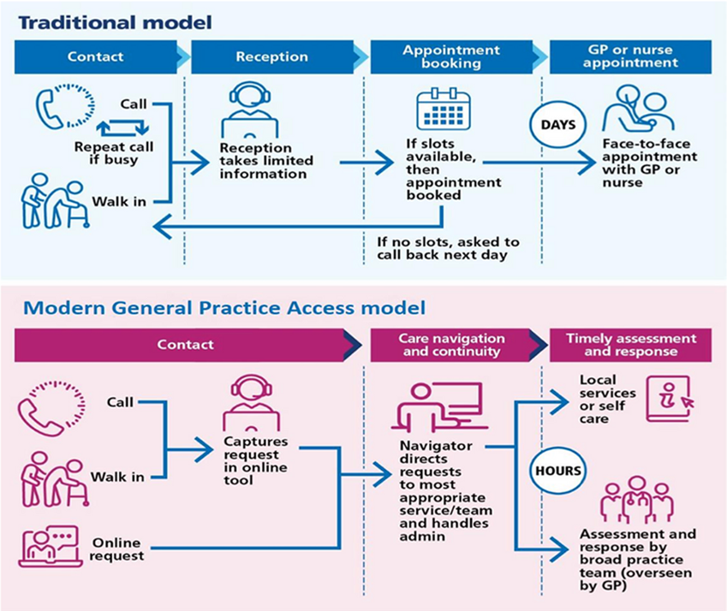

- Appointments

The group were still concerned about the lack of appointments, however, AC hoped that, by giving control of the appointments to the clinical team, access to appointments would improve. It was noted that other services available for the Care Navigators to book included:

- One You Lincolnshire for wellbeing and lifestyle support
- Pharmacy First which needs a clinical referral to trigger an appointment
- Acute Respiratory Hub
- Physiotherapist
- Mental Health Practitioner

MC confirmed the only appointments available to book on-line would be for routine Practice Nurse and Health Care Assistant appointments.

MC explained that there is still out of hours support via 111, Enhanced Access, Urgent Treatment Centre, and Emergency Care.

For information: Enhanced Access Services are available throughout the week at Louth Hospital and can be booked by the Care Navigators:
Monday | 18:30 hours to 20:00 hours
Tuesday | 18:30 hours to 20:00 hours
Wednesday | 18:30 hours to 20:00 hours
Thursday | 18:30 hours to 20:00 hours
Friday | 18:30 hours to 20:00 hours
Saturday | 09:00 hours to 17:00 hours
Sunday | No Service

For information: The Respiratory Hub is available until 31 March 2023 as outlined below for acute respiratory conditions.
Monday | 11:00 hours to 17:00 hours | Skegness Health Clinic, Skegness
Tuesday | 11:00 hours to 17:00 hours | Marisco Medical Practice, Sutton-on- Sea
Wednesday | 11:00 hours to 17:00 hours | Marisco Medical Practice, Sutton-on- Sea
Thursday | 11:00 hours to 17:00 hours | Marisco Medical Practice, Sutton-on- Sea
Friday | 11:00 hours to 17:00 hours | Newmarket Medical Practice, Louth
Saturday | 09:00 hours to 13:30 hours | Beacon Medical Practice, Ingoldmells
Sunday | 09:00 hours to 13:00 hours | Beacon Medical Practice, Ingoldmells

- Pharmacy First Service

There had been a lot of information recently in the national news outlining what services would be available to people from local pharmacies, these include:

- Urinary Tract Infections
- Shingles
- Impetigo
- Infected Insect Bites
- Acute Sore Throat
- Acute Sinusitis
- Acute Otis Media

MC informed the group that the Care Navigation Team would be completing referrals to local Pharmacies if patients meet the criteria. Patients would receive an appointment from the Pharmacy of their choice.

- GPs

It was noted that Dr Twomey had joined ELMG at the end of 2023 and was continuing to provide services at both The Wolds and Newmarket.

- Support Groups

SW was keen for the PPG to consider how the group could support patients. She asked everyone to consider the possibility of setting up a Support Group for patients with diabetes. This would be an agenda item at the next for everyone to feedback on their thoughts and ideas.

Any Other Business

Text Messages
Concern was raised that messages were still not specifying the site of the appointment and MC agreed to investigate this. It was noted that it would be helpful to have examples to review.

Ear Syringing
MC confirmed that ear syringing was available at the Practice and continues to be provided at the surgery. Patients need to have an initial assessment by a clinician before accessing this service.

Date of Next Meeting
The next meeting was scheduled for Friday 5 April at The Wolds Branch, Tetford.

